Report on the Comparison of AI-Enhanced Design Tools: Figma and Canva
1. Introduction
The purpose of this report is to evaluate and compare two design tools: Figma and Canva based on my experience using their free versions for our group project for this semester.
During this project, I used:
- Figma to design the Graphical User Interface (GUI) for KidTask project.
- Canva to create Activity Diagrams and Class Diagrams with the assistance of built-in AI features for BeePlan project.
This report first describes the work completed using each tool, then compares their usability, limitations, advantages, and overall suitability within the constraints of their free versions. Screenshots of the created GUI and diagrams are included at the end of the report.

2. Work Completed
2.1 KidTask’s GUI Design Using Figma
I used Figma to design an interactive and visually structured GUI for KidTask project.
The tool allowed me to:
- Create frames and define layout structures.
- Add UI components such as buttons, input fields, text blocks, and icons.
- Adjust spacing, alignment, colors, and typography efficiently.
- Organize design elements in layers.
- Use the daily free AI credit to generate additional UI ideas and speed up design adjustments.
Figma’s interface was intuitive, and the drag-and-drop functionality allowed for fast iteration.
Overall, Figma provided a smooth workflow for UI/UX design.

2.2 Activity and Class Diagrams Using Canva for BeePlan Project
I used Canva to create both Activity Diagrams and Class Diagrams for BeePlan.
Although Canva offers AI-supported diagram generation, using it in the free plan was challenging due to several limitations:
- Only one AI-generated diagram was allowed in the free version.
- Shapes, arrows, and connectors often required manual adjustments.
- Maintaining alignment and consistency between diagram elements was time-consuming.
- Customization of UML-specific shapes was limited.
Despite these challenges, I completed the required diagrams by manually editing the tool’s standard shapes and connectors.

3. Suitability for the Project
- Figma was ideal for GUI design, providing precise control and a natural workflow for interface creation.
- Canva was usable for UML diagrams but required much more manual effort and time, making it less suitable for technical diagramming under the free plan.

4. Figma – GUI Design for KidTask
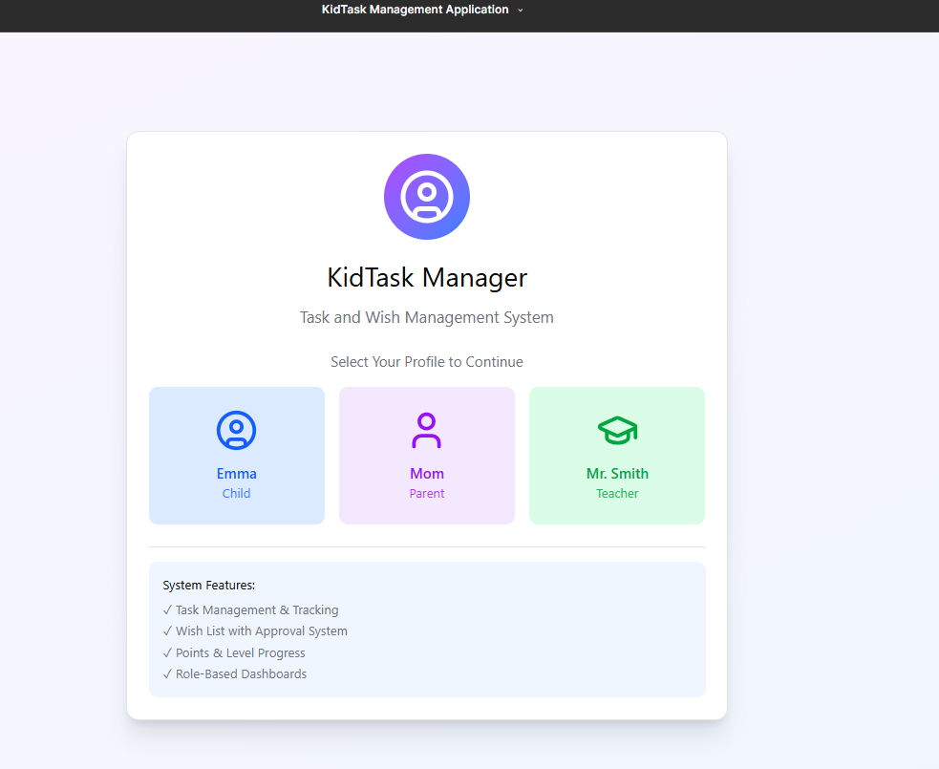
Page 1: Log-in page for KidTask

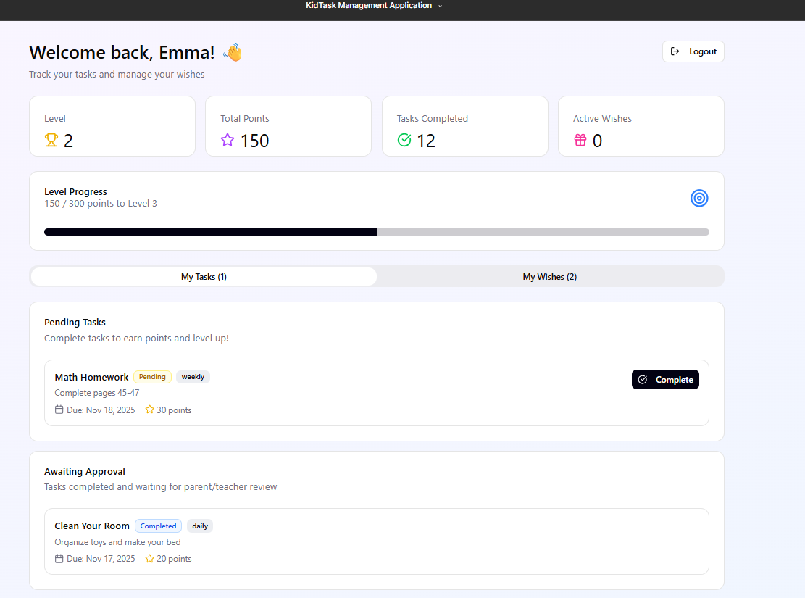
Page 2: Task Tracking and Wish Management for Child

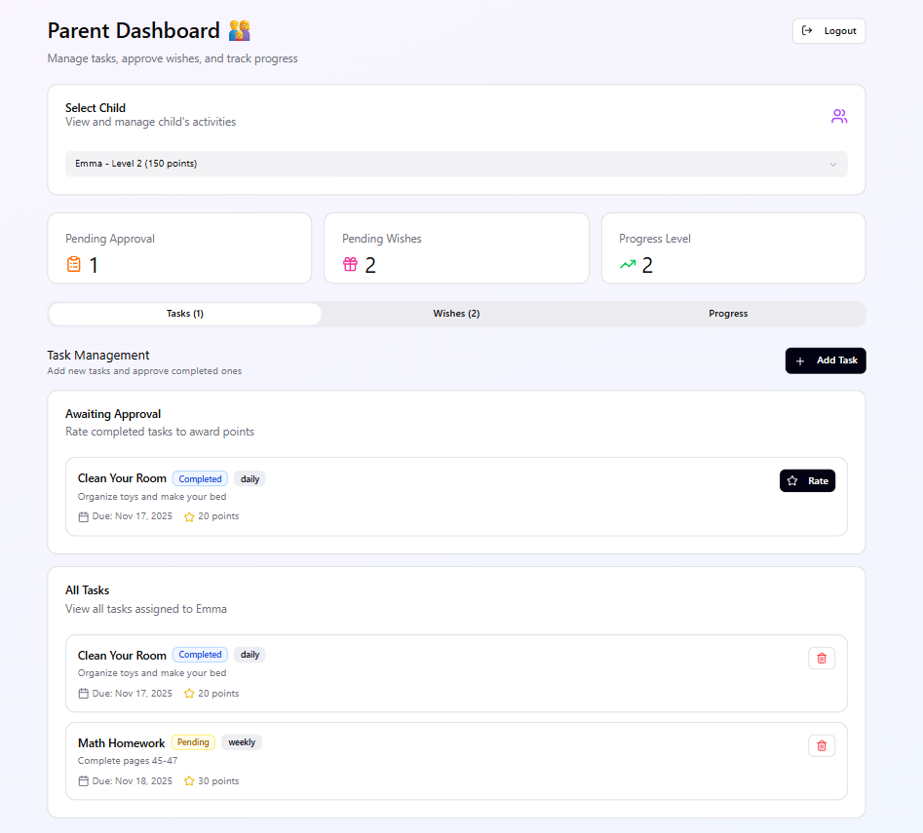
Page 3: Task Management and Wish Approval for Parents

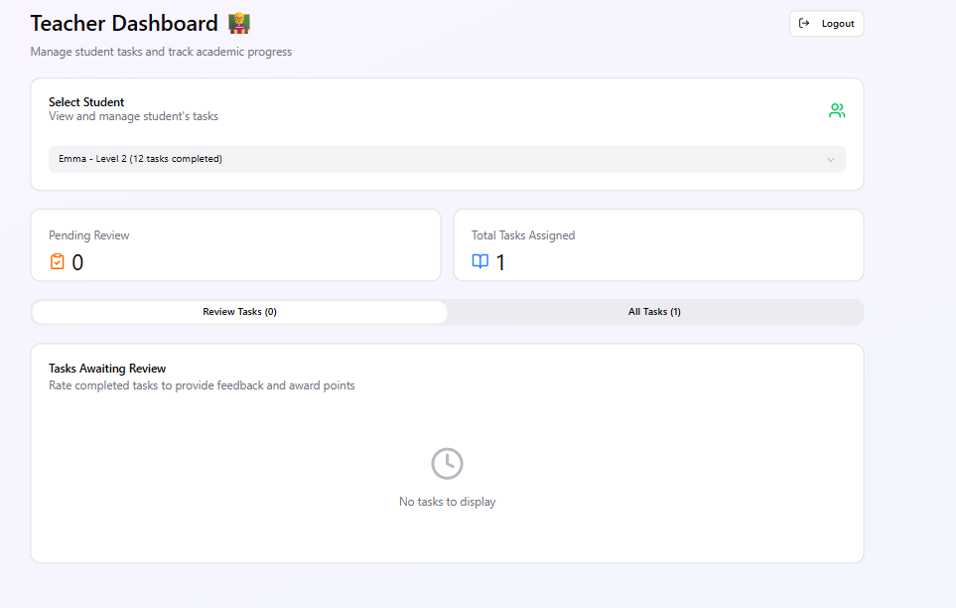
Page 4: Task Management and Tracking Progress of Students

5. Canva – Activity Diagram for BeePlan
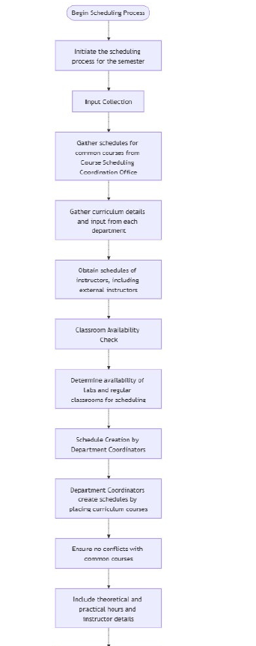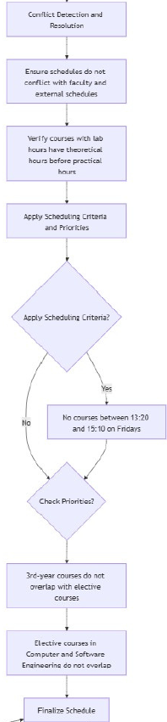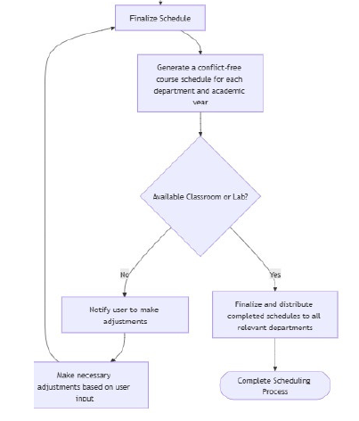
6. Canva- Class Diagram for BeePlan

